**Backup the Folders & Files from the directory and subdirectory**

Here first of all compressing a **files** folder and it’s all subdirectory

Example :-

Directory is which is backup to folder

**".\important\files\*.ps1”**

* First of all set the directory in one variable which are compressed

**$bkfile = ".\important\files"**

* And After the set path where the zip files are set

**$destination = ".\Backup\Archive.zip"**

Here, Archive.zip is name of the file to which are saved in backup folder

* After set the destination then the set the 7za.exe path whose describe the methods for the zip, unzipped file and more options are available
* 7zip are also download from the <http://www.7-zip.org/download.html>
* Here, 7za.exe provides the different commands and switches operation

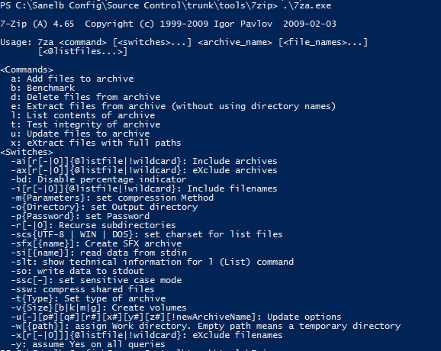

**$zip = ".\Source Control\trunk\tools\7zip\7za.exe";**

* Then the set the arguments for the compression and all of others operation

**[array]$args = @("a" , "-tzip" , "-y" ,$destination)+$bkfile;**

* After the execute $zip with the arguments

**& $zip $args;**